**NAAN MUDHALVAN PROJECT**

**FITNESS APP**

**BY**

**AAKASH R S**

**THRISHAL KUMAR**

**NAVEEN RAJ J**

**RAMESH M**

**DEEPAK KUMAR S**

1. **ABSTRACT**

Fit-Flex is a smart and user-friendly fitness app designed to make working out easier, more engaging, and more effective for everyone—whether you're just starting out or an advanced fitness enthusiast. In today’s fast-paced world, staying healthy and fit can be a challenge, but Fit-Flex provides a well-structured and interactive approach to fitness, making it accessible and enjoyable. With a simple and intuitive interface, Fit-Flex offers a vast library of exercises that users can explore based on their fitness levels and goals. Whether you’re looking for beginner workouts, strength training, yoga, or high-intensity routines, Fit-Flex has it all. The app is powered by modern technologies like React.js and API integrations, ensuring smooth performance and real-time updates on workouts, progress tracking, and community interactions. One of Fit-Flex's key features is its ability to adapt to each user’s needs. It offers AI-powered workout recommendations, video demonstrations for proper exercise form, and a smart tracking system that keeps users accountable. Additionally, the app fosters a strong fitness community where users can share their progress, join challenges, and stay motivated. Users can also set custom fitness goals and track their performance with detailed analytics.

Fit-Flex is more than just an exercise app—it’s a complete fitness companion. By incorporating artificial intelligence, cloud-based storage, and interactive community features, it ensures a personalized, goal-oriented, and highly engaging fitness experience. Whether you’re working out at home, at the gym, or on the go, Fit-Flex is designed to effortlessly keep you moving towards a healthier lifestyle. The app’s future scope includes deeper AI integration for automated workout recommendations and seamless connectivity with wearable devices to enhance user experience.

1. **PROJECT OVERVIEW**

**Project Title: Fit-Flex - Your Fitness Companion**

**Team Members: AAKASH R S -** aakashrs-cswithai@srmasc.ac.in

**NAVEEN RAJ J**  - [naveenrajj-cswithai@srmasc.ac.in](mailto:naveenrajj-cswithai@srmasc.ac.in)

**THRISHAL KUMAR H -** thrishalkumarh-cswithai@srmasc.ac.in

**DEEPAK KUMAR S** - [deepakkumars-cswithai@srmasc.ac.in](mailto:deepakkumars-cswithai@srmasc.ac.in)

**M RAMESH** - rameshm-cswithai@srmasc.ac.in

**2.1 Purpose**:

Fit-Flex's purpose is to provide a personalized fitness experience using AI-based workout recommendations and interactive features, ensuring users stay engaged and motivated. The app is designed to accommodate users of all fitness levels, from beginners to advanced athletes, by offering tailored workout plans, progress tracking, and a supportive fitness community.

**2.2 Key Features:**

- User authentication via Firebase for secure access

- Advanced search and filtering for workouts based on user preferences

- AI-powered workout suggestions tailored to fitness goals

- Video demonstrations for exercises with proper form guidance

- Community-driven challenges and progress sharing for motivation

- Real-time fitness tracking and history for improved progress monitoring

- Customizable workout plans for targeted fitness improvement

- Gamification elements like rewards and badges to keep users engaged

1. **ARCHITECTURE**

**3.1 Component Structure:**

1. The application follows a modular component-based architecture using React.js. Major components include:
2. Navbar.js – Handles navigation between pages, providing a smooth user experience
3. WorkoutCard.js– Displays individual workouts with details, including difficulty level and required equipment
4. SearchBar.js – Provides search and filtering functionality to help users quickly find relevant exercises
5. ExerciseList.js – Lists exercises retrieved from API with filtering and sorting options
6. Authentication.js – Manages user login/signup with Firebase Authentication
7. Profile.js– Displays user fitness data, goals, and saved workouts for tracking progress

**3.2 State Management:**

* Uses Context API to manage global state for user authentication, workout history, and progress tracking.
* Use State and use Effect to handle local states within individual components, ensuring efficient rendering and updates.
* Future updates may integrate Redux for better state management in complex interactions.

**3.3 Routing:**

React Router is used for navigation across the application, ensuring smooth transitions.

**- Key routes:**

- `/` (Home) – Overview of app features and quick access to workouts

- `/workout/:id` (Workout Details) – Displays exercise instructions and videos

- `/profile` (User Profile) – Tracks user progress and goals

- `/community` (Fitness Community) – Engages users through social fitness challenges

1. **SETUP INSTRUCTIONS**

**4.1 Prerequisites**

: Install the following dependencies before setting up the application:

Node.js & npm (Download from [nodejs.org] (https://nodejs.org/))

MongoDB (For storing user and workout data efficiently)

Firebase SDK (For authentication and secure data storage)

**4.2 Installation:**

```bash

git clone https://github.com/your-repo/fitflex.git

cd fit-flex

npm install

```

- Running the Application:

- Start the frontend:

```bash

cd client

npm start

```

- Start the backend:

```bash

cd server

npm start

1. **FOLDER STRUCTURE**

📂 Fit-Flex (Project Root)

├── 📂 client/ (Frontend - React.js)

│ ├── 📂 src

│ │ ├── 📂 components/ → Contains reusable UI elements (e.g., Navbar, Workout Card, Button)

│ │ ├── 📂 pages/ → Holds main screens (e.g., Home, Profile, Community)

│ │ ├── 📂 assets/ → Stores images, icons, and stylesheets

│ │ ├── 📂 context/→ Global state management (Context API)

│ │ ├── 📂 utils/ → Helper functions, custom hooks, and API handlers

│ │ ├── App.js → Main application component

│ │ ├── index.js → Entry point for React

│ │ ├── Routes.js → Handles navigation

│ ├── package.json → Dependencies and project metadata

│ ├── tailwind.config.js → Tailwind CSS configuration

│ ├── vite.config.js → Build and optimization settings

├── 📂 server/ (Backend - Node.js & Express)

│ ├── 📂 models/ → Database schemas for users and workouts (MongoDB)

│ ├── 📂 routes/ → API endpoints (Auth, Exercises, Workouts)

│ ├── 📂 controllers/ → Business logic for routes

│ ├── server.js → Main backend server file

│ ├── database.js → Database connection settings

│ ├── package.json → Backend dependencies

├──.git ignore → Files to ignore in version control

├── README.md → Project documentation

This structure ensures clear separation of concerns, easy debugging, and efficient development.

**5.1 Client Structure**

The Fit-Flex React application is well-organized into several key directories, ensuring modularity and ease of development:

- Components: Houses reusable UI elements such as buttons, cards, and navigation bars.

- Pages: Includes major screens like Home, Workout Details, Profile, and Community.

- Assets: Stores static resources such as images, icons, and videos.

- Context: Manages global states for authentication, user progress, and API data.

- Utils: Contains helper functions, custom hooks, and utility classes to streamline data manipulation.

This structure ensures a clean codebase that is easy to maintain and scale.

**5.2 Utilities**

The utility folder contains helper functions, utility classes, and custom hooks used throughout the application:

- API Helper Functions: Handles API requests to fetch workout data efficiently.

- Custom Hooks: Includes use of Fetch and Auth hooks for data fetching and authentication management.

- Data Formatting Functions: Converts and processes workout data before rendering it in components.

- Validation Utilities: Ensures user input data integrity for authentication and profile management.

These utilities reduce code redundancy and improve maintainability.

1. **RUNNING THE APPLICATION**

- Start the frontend:

```bash

cd client

npm start

```

- Start the backend:

```bash

cd server

npm start

```

This launches the frontend on `localhost:3000` and the backend API on `localhost:5000`.

1. **COMPONENT DOCUMENTATION**

**7.1 Key Components:**

- Navbar.js: Provides top-level navigation.

- WorkoutCard.js: Displays individual workout details.

-SearchBar.js: Enables users to search and filter workouts.

- ExerciseList.js: Lists all available exercises retrieved from API.

- Authentication.js: Manages user login/signup.

- Profile.js: Displays user progress, history, and goals.

**7.2 Reusable Components:**

- Button.js: A customizable button component.

- Modal.js: Used for pop-ups and alerts.

- Card.js: Displays structured content like workout details.

1. **STATE MANAGEMENT**

**Global State Management:**

- Uses Context API to handle authentication, user workout history, and API data sharing across the application.

- Future updates may integrate Redux for enhanced scalability and better state handling.

**Local State Management:**

- Utilizes use State and use Effect hooks to manage component-specific data.

- Ensures smooth rendering and interaction with UI elements.

1. **USER INTERFACES & SCREENSHOT**

- The UI follows a minimalist design for a smooth user experience.

- Features interactive elements such as animated buttons and transition effects.

- The dashboard provides an overview of workouts, progress, and achievements.

- The community section allows users to engage, comment, and share fitness milestones.

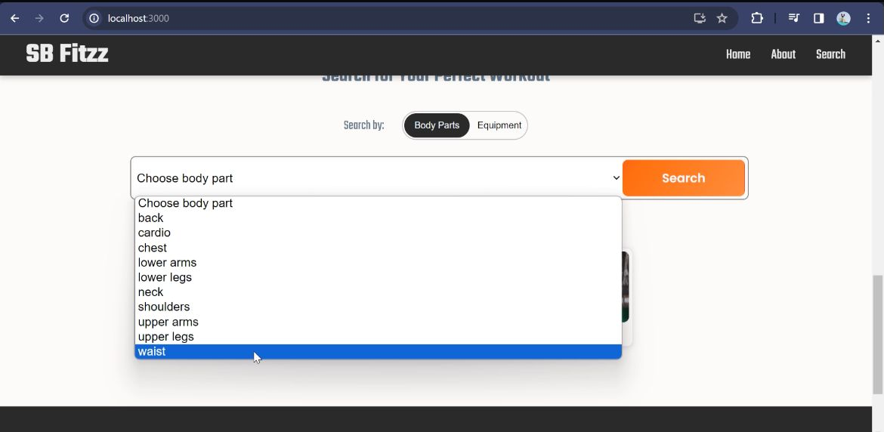

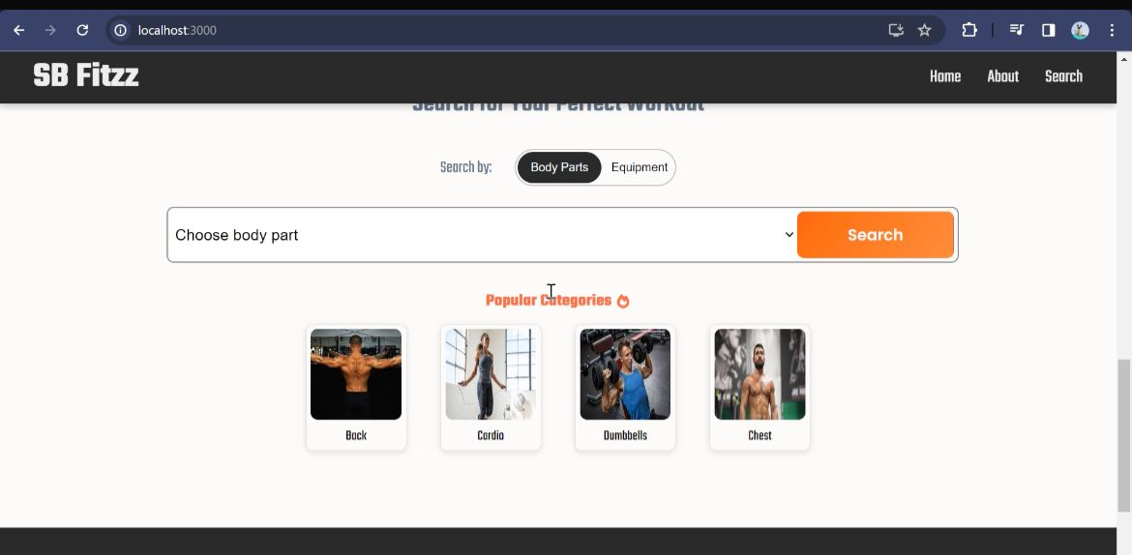

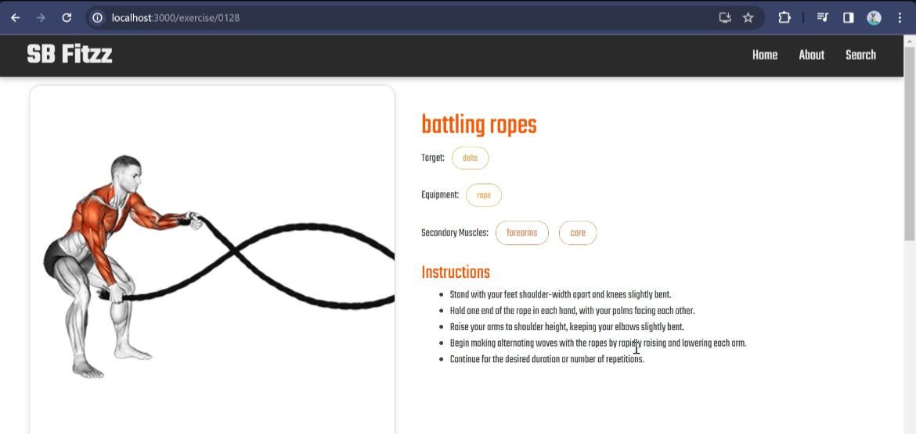

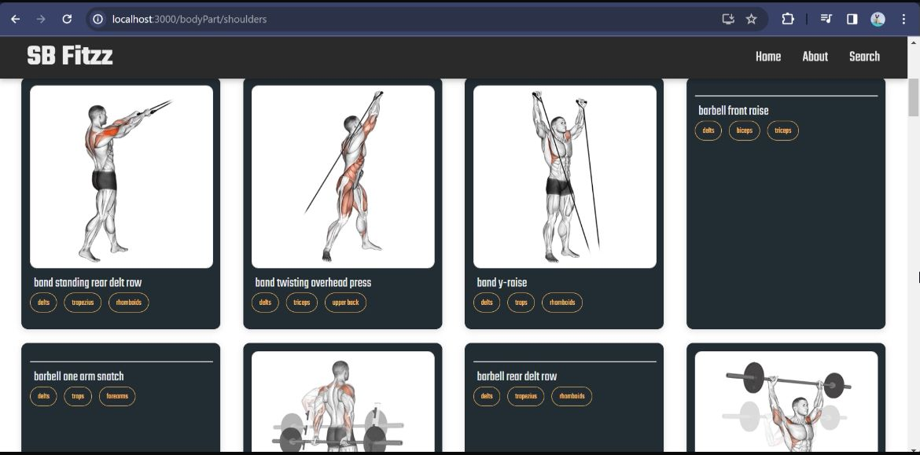

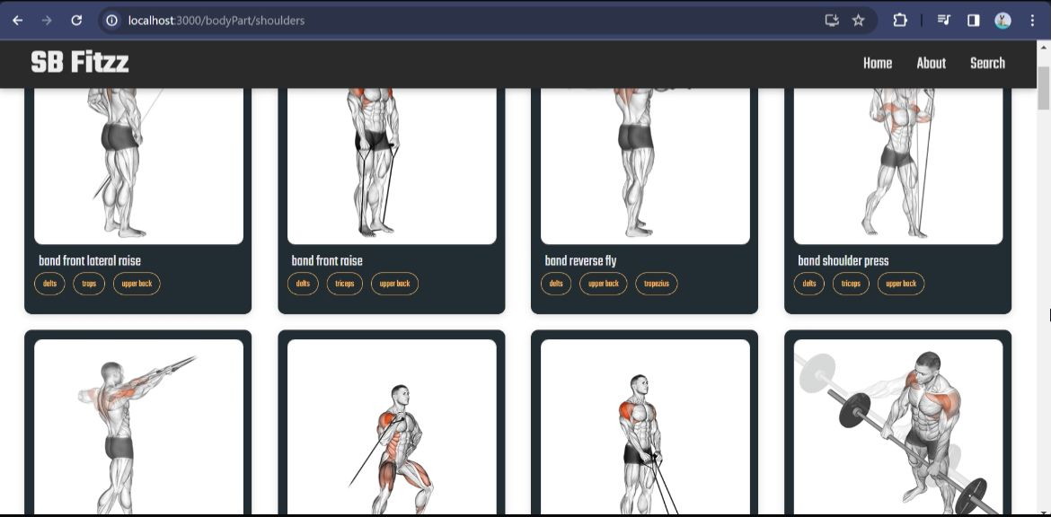

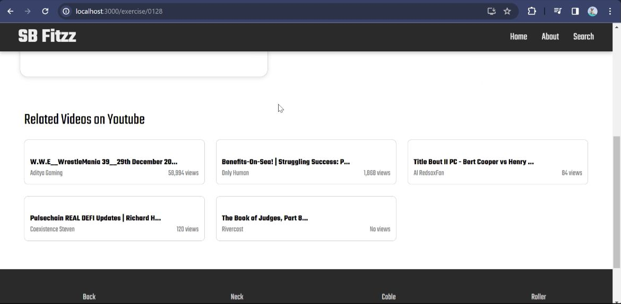

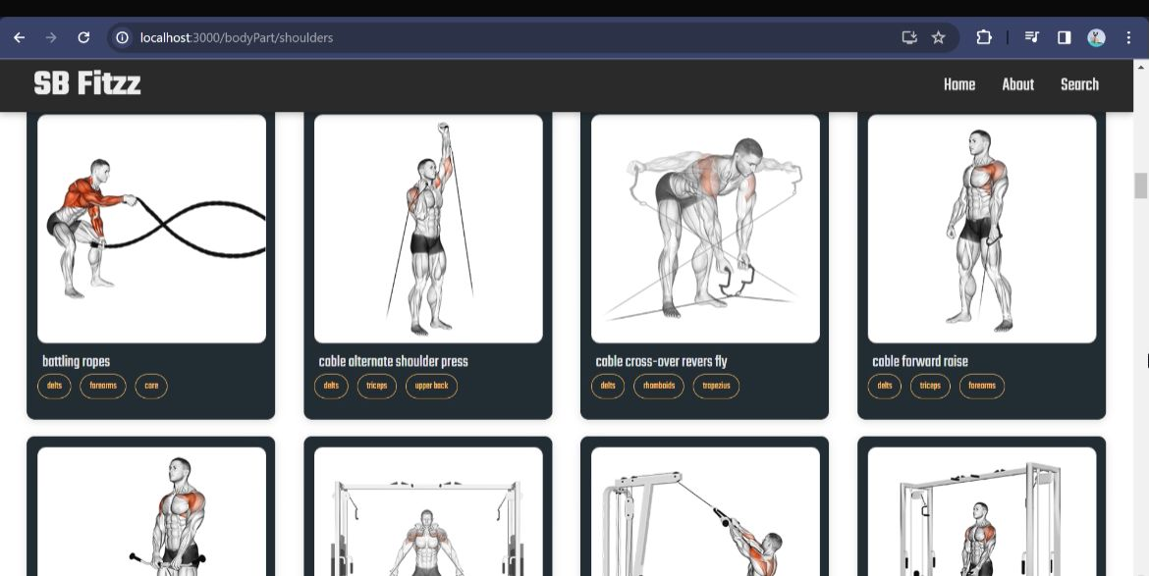

1. **STYLING**

**- CSS Frameworks/Libraries:**

- Uses Tailwind CSS for a modern and flexible design.

- Includes Styled Components for component-level styling and customization.

- Supports Sass for advanced styling features and better modularization.

**- Theming:**

- A light and dark mode switch is implemented for user preference.

- Uses CSS variables for dynamic styling.

1. **TESTING**

**- Testing Strategy:**

- Uses Jest and React Testing Library for unit and integration testing.

- API endpoints are tested using Postman and Super tests to validate data retrieval and storage.

- Cypress is used for end-to-end testing, simulating real user interactions with the app.

**- Test Coverage:**

- Ensure at least 80% test coverage for core functionalities, including authentication, API integration, and state management.

- Automated testing pipelines are implemented using GitHub Actions for continuous integration.

1. **KNOWN ISSUES**

Despite the robust development of Fit-Flex, there are a few known issues that users and developers should be aware of:

1. Performance Lag on Low-End Devices – Some users with older smartphones or limited processing power may experience lag when navigating through high-resolution workout videos or animations.

2. Limited Offline Mode – The application requires an internet connection to fetch workout data and track progress. A fully functional offline mode is not yet available.

3. Delayed API Response – Occasionally, external API requests (e.g., fetching workout details) may take longer than expected due to server limitations or network issues.

4. User Authentication Glitches – Some users have reported intermittent login/logout issues, particularly when switching devices.

5. Inconsistent Video Playback – Some embedded exercise videos may not load correctly due to API restrictions or missing video links.

6. State Persistence Issues – In some cases, user progress may not immediately reflect after completing a workout session due to delayed synchronization with the database.

7. Limited Wearable Device Support – Currently, Fit-Flex does not fully support all fitness tracking devices such as Apple Watch or Garmin.

8. Buggy Dark Mode Implementation – Some UI elements may not render properly when switching between light and dark modes.

9. Community Feature Enhancements Needed – The social engagement aspect of Fit-Flex (commenting, likes, and sharing) lacks real-time updates and improved moderation features.

10. High Battery Consumption – Prolonged usage of the app, especially when running high-intensity workout videos, can drain battery life faster than expected.

1. **FUTURE ENHANCEMENT**

Fit-Flex is designed with scalability in mind, and several enhancements are planned for future versions:

Live Workout Classes: Integration of real-time virtual fitness sessions with expert trainers for guided workouts.

Wearable Device Integration: Support fitness trackers (e.g., Apple Watch, Fitbit) to track heart rate, calories burned, and activity levels in real-time.

AI-Powered Coaching: Advanced machine learning models to provide AI-driven feedback on exercise performance, posture correction, and form improvement.

VR-Assisted Workouts: Immersive VR-based training experiences for a more engaging and interactive workout session.

Multi-Language Support: Expanding the app to cater to users worldwide with multiple language options.

Dietary & Nutrition Guidance: AI-driven meal planning suggestions based on fitness goals, calorie intake, and activity levels.

Offline Mode: Allowing users to download workout routines and access them without an internet connection.

1. **CONCLUSION**

Fit-Flex is redefining the fitness app experience by combining smart technology, interactive features, and user-friendly design. It eliminates the common frustrations of traditional fitness apps by offering personalized workouts, seamless tracking, and a strong community-driven approach. Whether you are starting your fitness journey or looking to take it to the next level, Fit-Flex provides all the tools and motivation needed for success.

With plans to integrate live fitness classes, VR-assisted workouts, and even more AI-powered customization, Fit-Flex is set to become the ultimate fitness companion for users worldwide. The future roadmap includes further enhancements in AI-driven recommendations, deeper API integrations, and stronger community engagement features to make Fit-Flex the go-to fitness platform for everyone.